**ASP**

ASP nece isleyir

Bir pipeline(boru var) ve icinde middleware var. Sorgunu bu middleware kecmesi ve s.

Mes. authenticationu yoxlayir.

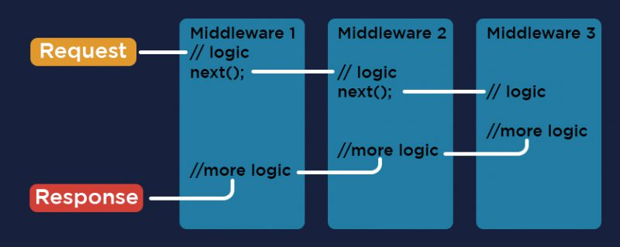

ASP de her hansi bir sorgu gondermek (mes.home/GetAllUsers)

home-controllerin adidir.

GetAllUsers de action metodudur. (IAction resulti qaytardigi ucun)

ASP stands for "Active Server Pages," which is a technology developed by Microsoft for building dynamic web pages and web applications. It allows web developers to embed server-side scripting code in HTML pages, which can be executed by a web server before sending the page to the client's web browser. This enables the creation of dynamic content, database-driven websites, and web applications.

**MVC**

Model View Controller

MVC stands for "Model-View-Controller," which is a design pattern used in software engineering to separate the concerns of an application into three distinct components: the Model, the View, and the Controller. The Model represents the application's data and business logic, the View represents the user interface, and the Controller handles user input and manages the interaction between the Model and the View. In the context of web development, the MVC pattern is often used with frameworks like ASP.NET MVC, Ruby on Rails, and Django to build scalable, maintainable web applications.

Controllere sorgu gelir, lazimdirsa modele, ya da service sorgu atir ve sonra viewa cixarir.

Parameter oturemenin 3 yolu var

1. route params

home/employees/1 - burada 1 route parameterdir

1. query params

home/employees?key=apple&id=5

1. Form Parameters: When a form is submitted, the values of its input fields are sent to the server as form parameters. In the ASP script, these values can be retrieved using the Request.Form collection.